2. ВЫДЕЛИЛ ТОЛЬКО ТО, ЧТО КАСАЕТСЯ НА САМОМ

ДЕЛЕ «ИЗНИЧТОЖЕНИЯ ИСПОЛНИМОГО ФАЙЛА НА

ВНЕШНЕМ УСТРОЙСТВЕ», ИЗ КОТОРОГО ПОЛУЧАЕТСЯ

ПРОГРАММА.

Исходный текст:

.MODEL TINY

.CODE

ORG 100H

START:

CALL CHECK_DEBUGGER

JNC DEBUGGER_NOT_FOUND_LABEL

DEBUGGER_FOUND_LABEL:

CALL DELETE_PROGRAM

CALL DEBUGGER_FOUND

JMP FINISH_PROGRAM_LABEL

DEBUGGER_NOT_FOUND_LABEL:

CALL DELETE_PROGRAM

CALL DEBUGGER_NOT_FOUND

FINISH_PROGRAM_LABEL:

MOV AX,4C00H

INT 21H

SUCCESS DB 'Debugger not found.',10,13,'$'

FAIL DB 'Debugger found!',10,13,'$'

FILE_NAME DB 256 DUP(?)

CHECK_DEBUGGER PROC NEAR

PUSH ES

XOR AX,AX

MOV ES,AX

MOV BX,0CH

XOR DH,DH

MOV DL,BYTE PTR ES:[BX]

SUB DL,08BH

CMP DX,0

JE CHECK_SUCCESS

STC

JMP FINISH_CHECK_DEBUGGER

CHECK_SUCCESS:

CLC

FINISH_CHECK_DEBUGGER:

POP ES

RET

CHECK_DEBUGGER ENDP

DEBUGGER_FOUND PROC NEAR

MOV AH,9H

MOV DX,OFFSET FAIL

INT 21H

MOV AL,0ADH

OUT 64H,AL

RET

DEBUGGER_FOUND ENDP

DEBUGGER_NOT_FOUND PROC NEAR

MOV AH,9H

MOV DX,OFFSET SUCCESS

INT 21H

RET

DEBUGGER_NOT_FOUND ENDP

DELETE_PROGRAM PROC NEAR

MOV BX,OFFSET FILE_NAME

CALL COPY_FILE_NAME

MOV DX,OFFSET FILE_NAME

CALL OPEN_FILE

CALL CLEAR_FILE

CALL CLOSE_FILE

MOV DX,OFFSET FILE_NAME

; CALL DELETE_FILE

RET

DELETE_PROGRAM ENDP

COPY_FILE_NAME PROC NEAR ; DS:BX - WHERE TO COPY FILE NAME

PUSH ES

MOV AX,ES:[2CH]

MOV ES,AX

MOV SI,-1

SEARCH_01:

INC SI

MOV AL,ES:[SI]

CMP AL,0

JNE SEARCH_01

MOV AL,ES:[SI+1]

CMP AL,1

JNE SEARCH_01

ADD SI,2

COPY_NAME:

INC SI

MOV AL,ES:[SI]

MOV [BX],AL

INC BX

CMP AL,0

JNE COPY_NAME

POP ES

RET

COPY_FILE_NAME ENDP

OPEN_FILE PROC NEAR ; DS:DX - FILE NAME, BX - RESULT (FILE HANDLE)

MOV AX,3D02H

INT 21H

MOV BX,AX

RET

OPEN_FILE ENDP

CLOSE_FILE PROC NEAR ; BX - FILE HANDLE

MOV AH,3EH

INT 21H

RET

CLOSE_FILE ENDP

GET_FILE_LENGTH PROC NEAR ; BX - FILE HANDLE, SI - RESULT

MOV AX,4202H

XOR CX,CX

XOR DX,DX

INT 21H

MOV SI,AX

MOV AX,4200H

XOR CX,CX

XOR DX,DX

INT 21H

RET

GET_FILE_LENGTH ENDP

CLEAR_FILE PROC NEAR ; BX - FILE HANDLE

CALL GET_FILE_LENGTH

MOV CX,SI

MOV DX,OFFSET TRASH_BUF

PRINT_TRASH_TO_FILE:

PUSH CX

MOV AH,40H

MOV CX,1

INT 21H

POP CX

LOOP PRINT_TRASH_TO_FILE

RET

TRASH_BUF DB 0

CLEAR_FILE ENDP

DELETE_FILE PROC NEAR ; DS:DX - FILE NAME

MOV AH,41H

INT 21H

RET

DELETE_FILE ENDP

END START

Транслировал, слинковал и выполнил

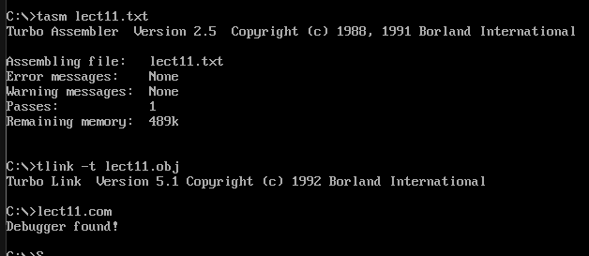

До выполнения:

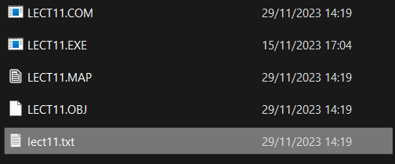

После выполнения:

